Department of Statistics

The Wharton School

University of Pennsylvania

STAT 603 August 2004

Module 6

Covariance and Portfolios

Dependence and Independence
In many situations, we will be interested in the simultaneous outcomes of two or more random variables.
For a randomly chosen person, we could define X = height and Y = weight
For a randomly selected store selling a particular product, X = price and Y = sales
For next January, X = return on GM and Y = return on Ford

We can think of each of these pairs as a draw from a population of (x,y) values.

Definition: If knowing the outcome of X changes the probability distribution of Y (or vice-versa), then the rv's X and Y are said to be dependent. Otherwise, X and Y are said to be independent.

Are the above pairs of rv's dependent? How?
Linear Association

Suppose that we repeat the process that attaches values to X and Y, and then plot the joint outcomes. The plot might resemble one of the following:

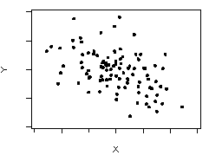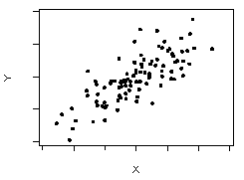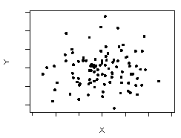
Note that X and Y vary together along the diagonals in the first two plots.

Which of these would you associate with the previous X,Y pairs?

The tendency to cluster along the diagonals (seen in the first two plots) is called linear association

Does linear association imply dependence?

Does dependence imply linear association?
Covariance and Correlation
Covariance and correlation measure linear association.

They are obtained as follows. Let μ_{X}, μ_{Y}, σ_{X}, σ_{Y} denote the means and standard deviations of X and Y, respectively.

Covariance

The covariance between X and Y is defined as

Cov(X,Y) = E[(X− μ_{X})(Y−μ_{Y})]

Intuition: (When you see “E”, think “on average.”)

When (X− μ_{X}) and (Y−μ_{Y}) have the same sign, the contribution of
[(X− μ_{X}) (Y−μ_{Y})] to Cov(X,Y) is positive; otherwise it is negative.

Bad news: Covariance depends on the units in which X and Y are measured.

Correlation
The correlation between X and Y is defined as

ρ_{XY} 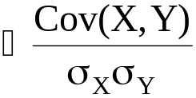

Good news: ρ_{XY} is unit-free. It is a pure measure of linear association.

ρ_{XY} has the same sign as Cov(X,Y) but satisfies −1 ≤ ρ_{XY} ≤ 1.

Cov(X,Y) > 0 and ρ_{XY} > 0 indicate positive linear association.

Cov(X,Y) < 0 and ρ_{XY} < 0 indicate negative linear association.

Cov(X,Y) = 0 and ρ_{XY} = 0 indicate no linear association.

ρ_{XY} = 1 (or −1) indicates perfect positive (or negative) linear association.

What are the signs of Cov(X,Y) and ρ_{XY} in the three plots on page 6-2?
Correlation and Independence

Cov(X,Y) ≠ 0 or ρ_{XY} ≠ 0 implies that X and Y are dependent

ρ_{XY} ≠ 0 implies Dependence

X and Y independent implies Cov(X,Y) = 0 and ρ_{XY} = 0

Independence implies ρ_{XY} = 0

Careful!

Cov(X,Y) = 0 or ρ_{XY} = 0 does not imply independence. Why?

Think of a plot of data that has ρ_{XY} = 0 but is not independent. Think: dependence means knowing the position along the x-axis helps you to predict the position along the y-axis.
The Sample Estimates of Cov(X,Y) and ρ_{XY}

Quantities like μ_{X}, μ_{Y}, σ_{X}, σ_{Y}, Cov(X,Y) and ρ_{XY} are properties of the population
from which X and Y were drawn.

Typically, we won’t know these distributions, but will instead have a sample of n observations (x₁,y₁),…,(x_{n},y_{n}).

Examples:

For n individuals, x_{i} = height, y_{i} = weight

For n days, x_{i} = return on Disney, y_{i} = return on McDonalds

As described in Module 2, μ_{X}, μ_{Y}, σ_{X}, σ_{Y} are estimated by 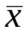, 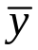, 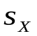 and 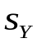, which are functions of (x₁,y₁),…, (x_{n},y_{n}).

Similarly, Cov(X,Y) and ρ_{XY} are estimated by functions of (x₁,y₁),…, (x_{n},y_{n}).

JMP will calculate all of these, but if you must know, the formulas for the estimators of Cov(X,Y) and ρ_{XY} are

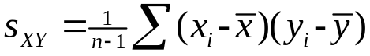 and 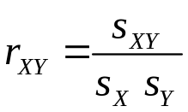

All of the quantities , , , , 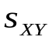, 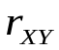 are also useful as descriptive summary statistics of data.
Weighted Sums of Random Variables

A weighted sum of random variables X and Y is

(a X + b Y)

where a and b stand for fixed numbers that are not random. These are familiar; a portfolio of 2 stock investments is just a weighted average of 2 random variables.

Jargon - Weighted sums such as these are often called linear combinations

We can use weighted sums of random variables to represent portfolios of investments.

Example: From Module 5, Pink = .5 Red + .5 White

We will now see that

E(a X + b Y) can be easily expressed in terms of E(X) and E(Y)

Var(a X + b Y) can be easily expressed in terms of Var(X), Var(Y) and Cov(X,Y)
FACT #1
For any weighted sum of random variables

E(a X + b Y) = a E(X) + b E(Y)

In Module 5 (pg 5-15), we saw a special case of this formula

E(Pink) = E (.5 Red + .5 White)
= .5 E(Red) + .5 E(White)
= .5 (1.71) + .5 (1.08) = 1.359
FACT #2
For any weighted sum of random variables,

Var(a X + b Y) = a² Var(X) + b² Var(Y) + 2ab Cov(X,Y)

In Module 5 (pg 5-15), we saw a special case of this formula

Var(Pink) = Var(.5 Red + .5 White)
=.5² Var(Red) + .5² Var(White) + 2(.5)(.5)Cov(Red,White)
=.5² (1.755) + .5² (.002) = .439

What happened to the Cov(X,Y) term here?

FACT #3
For any weighted sum of independent random variables

Var(a X + b Y) = a² Var(X) + b² Var(Y)
Some useful special cases of these facts:

E(a X) = a E(X), Var (a X) = a² Var(X), SD(a X) = |a| SD (X)

For independent X and Y, the variance of a sum is the sum of the variances

Var (X +Y) = Var (X) + Var (Y), SD(X + Y) = 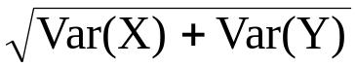

The same applies to differences

Var (X – Y) = Var (X) + Var (Y), SD(X – Y) =

The Mean and Variance of Some Real Portfolios

Let’s now move beyond the Pink portfolio and consider portfolios of real stocks. Two new aspects need to be considered:

- Returns on the individual investments are typically not independent of each other

- The probability distributions of the returns on the individual investments are unknown

Thus

1) We cannot assume independence

2) The unknown characteristics must be estimated from data

Stock Market Data Files
StockReturns.jmp contains the monthly (net) returns on the stocks of 35 companies from 1975-1999. StockReturnsSummary.jmp contains a summary of these returns.
These data were obtained from the Center for Research in Security Prices (CRSP), which is available to you on WRDS. Another analysis of stocks appears in BBS (p. 197-204).

The 35 companies were chosen as the dominant companies in 7 industries in December 1974. Note that only 22 firms have data that spanned the entire 300 month period.
The following output summarizes the volatility-adjusted returns for all 35 stocks. The highlighted stocks lasted less than 200 months during 1975-1999.

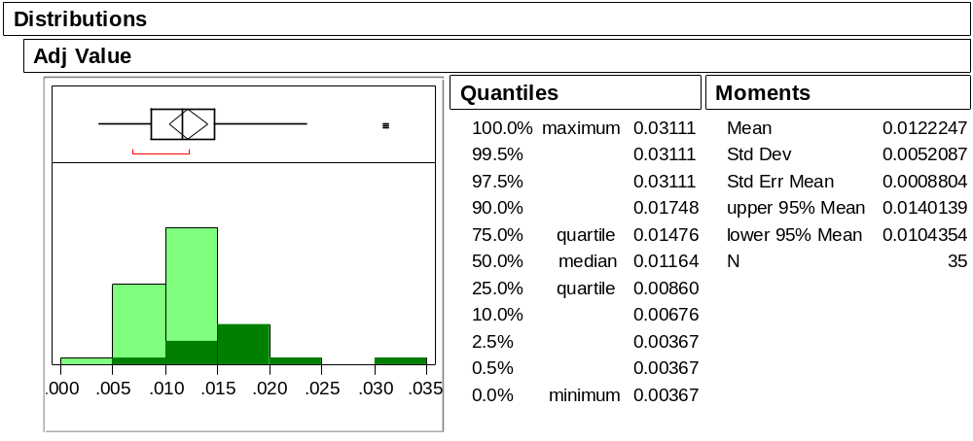
What happened to the firms that dropped out of the sample?
Of the stocks that survived the whole 25 years (300 months), Disney had the highest volatility-adjusted return 0.0149. Exxon was a close second with adjusted return 0.0148.

Let’s combine these into the equally-weighted portfolio DisExx= .5 Disney + .5 Exxon

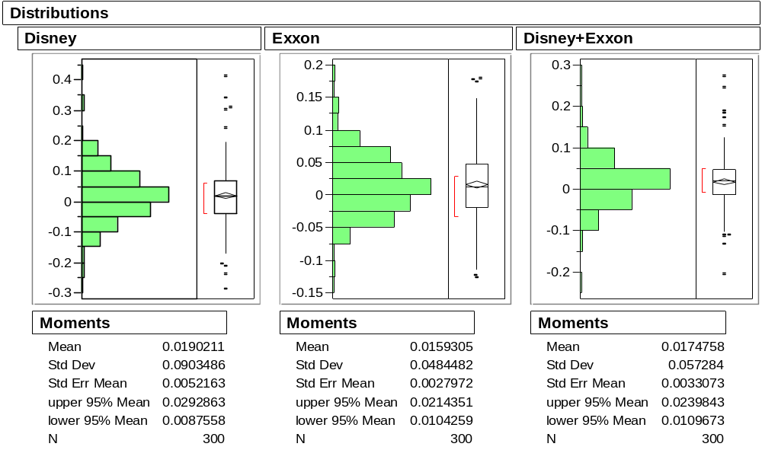
From these summaries we obtain the volatility-adjusted returns as follows:

Investment | Average | Variance | Avg – Var/2
Disney | .0190 | .0082 | .0149
Exxon | .0159 | .0023 | .0148
DisExx | .0174 | .0033 | .0158

Once again, a portfolio offers an improvement in long-term gains over investing 100% in either of the individual investments.

Role of Covariance
For the equally weighted portfolio of Disney and Exxon stocks, the return on the portfolio is just the average of the returns on the two stocks

Avg(DisExx) = .01774 = .5(.0190) + .5(.0159)

but for the variance we find

Var(DisExx) = .0033 ≠ .5²(.0082) + .5²(.0023)

which was the formula we used for Pink. What’s missing?

Using the complete formula for the variance of a weighted sum (Fact #2, page 6-11), the value of Var(DisExx) implies

.0033 = .5²(.0082) + .5²(.0023)+ 2(.5)(.5)Cov(Dis, Exx)

Solving for the Cov term, we can calculate that the covariance between Disney and Exxon is Cov(Dis, Exx) = .00131

We can see that Disney and Exxon are related, though only weakly.
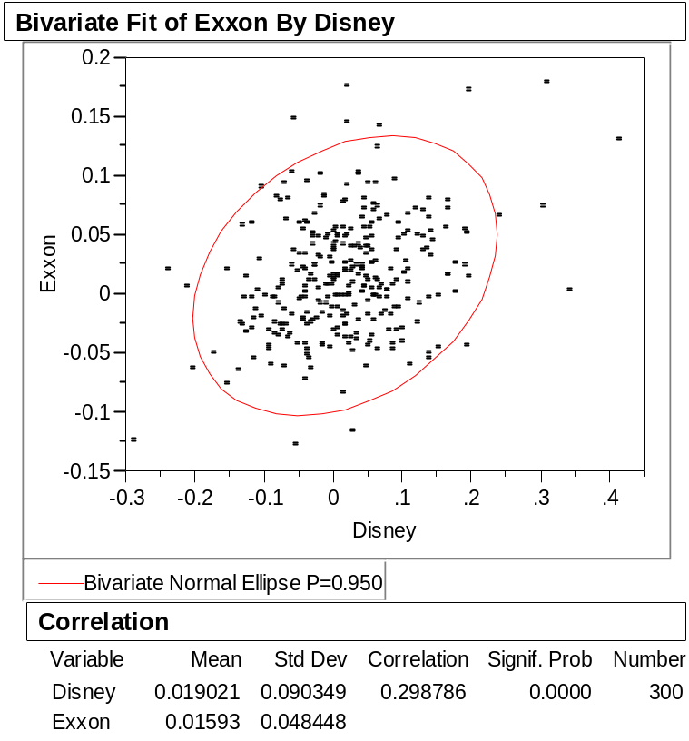
Note that the sample correlation between Disney and Exxon is .298
(= .00131/(.090)(.0484)).
Let’s now consider pairing Disney with McDonalds which had the third largest volatility adjusted return, at .0142.
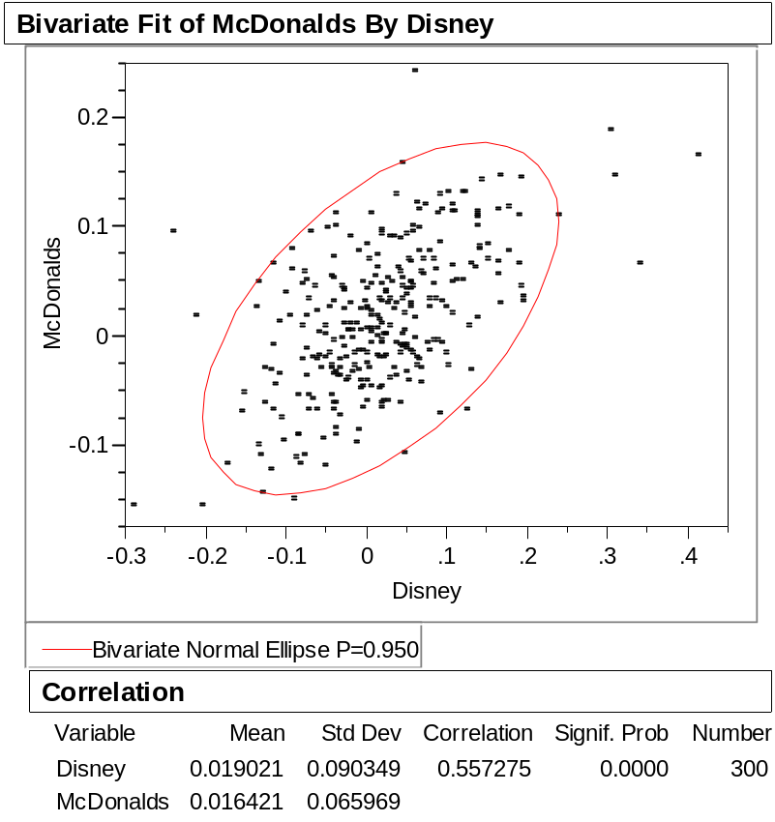

Compared to Exxon, McDonalds has a larger average return .0164, but McDonalds also has a larger variance .0044 and a higher correlation .557 with Disney. The plot confirms the stronger positive relationship (notice the more flattened elliptical shape).
For the equally-weighted portfolio of Disney and McDonalds we obtain

Investment | Average | Variance | Avg – Var/2
Disney | .0190 | .0082 | .0149
McDonalds | .0164 | .0044 | .0142
DisMcD | .0177 | .0048 | .0153

DisMcD does not outperform DisExx. Why?
Constructing an “Optimal” Portfolio
The pairwise portfolios that we have considered thus far put equal weight on the two stocks in the portfolio.

More generally, for two investments with returns X and Y, we could consider portfolios of the form
Z = p X + (1-p) Y

where p is the proportion of the total invested in X.

Given the means, variances, and covariance between X and Y, we can use our previous facts to obtain

E(Z) = p E(X) + (1-p) E(Y)

Var(Z) = p² Var(X) + (1-p)² Var(Y) + 2p(1-p) Cov(X,Y)

An “optimal” portfolio can then be obtained by choosing the value of p which maximizes the volatility adjusted return, E(Z) – Var(Z)/2.

This problem can be solved with the Solver in Excel.

For example, the optimal Disney-Exxon portfolio is .52 Disney + .48 Exxon yielding a volatility adjusted return of .0158 (only a small improvement).

The optimal Disney-McDonalds portfolio is .62 Disney + .38 McDonalds yielding a volatility adjusted return of .0154 (again only a small improvement).
Larger Portfolios
More importantly, why restrict portfolios to only two investments?

More generally, for K investments X₁,…,X_{K} and weights p₁,…,p_{K} (that sum to 1), the general form of a portfolio is given by (another linear combination, just bigger)

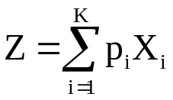

The mean and variance of Z are given by the formulas

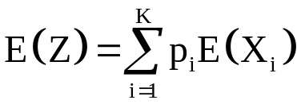
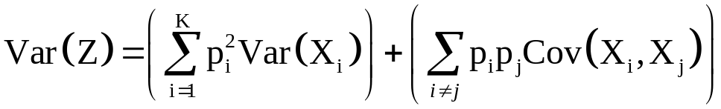

(Remain calm – these formulas are just straightforward generalizations of the two variable formulas)
As before, an “optimal” portfolio might then be obtained by choosing the values of p₁,…,p_{K} which maximize the volatility adjusted return E(Z) – Var(Z)/2.

Another strategy that is sometimes considered fixes the “risk” of the portfolio (its variance) and then chooses the values mixture weights p₁,…,p_{K} that maximize the expected return.

For example, using the Solver in Excel we find that for a portfolio of a subset of our 35 stocks
Var(Z) | Maximum E(Z) | E(Z) - Var(Z)/2
0.00135 | 0.0139 | 0.013225
0.00140 | 0.0149 | 0.014200
0.00150 | 0.0161 | 0.015350
0.00200 | 0.0191 | 0.018100
0.00300 | 0.0225 | 0.021000
0.00400 | 0.0250 | 0.023000
0.00500 | 0.0271 | 0.024600

Note how increased volatility allows for increased expected returns.
For our previous two stock portfolios we found

Investment | Average | Variance | Avg – Var/2
DisMcD | .0177 | .0048 | .0153
DisExx | .0174 | .0033 | .0158

How do the larger portfolios compare to these?

Caveats!

The means, variances and covariances may change in the future. Remember Long Term Capital Management?

Future inflation should also be considered along with the cost of borrowing.

Take-Away Review

Portfolios can be represented as weighted sums of random variables, allowing us to study methods for optimizing the performance of a portfolio.

Finding the variance of such a portfolio requires that we know the covariances among the different investments.

Covariance and correlation measure the strength of linear association between pairs of random variables.

Cov(X,Y) ≠ 0 implies dependence, but
Cov(X,Y) = 0 does not imply independence.

Covariance is more useful for working with portfolios, but correlation will become more useful in Stat 621.

Next Module

Samples and populations are key ideas in inferential statistics, and we next take a closer look at these concepts.

It seems natural that the variance of a sum might be the sum of the variances. But why should the variance of the difference also be the sum of the variances? It might help to think of Var(X-Y) as Var(X+(–Y)) = Var(X) + Var(–Y). Changing the sign of Y does not change its variance, Var(Y) = Var(–Y).
As in the dice simulation, this portfolio rebalances after each month so that half of the value of the portfolio is kept in Disney, and the other half in Exxon.
We can get the variance by simply squaring the SD that appears in the output. You can also ask JMP to give you the variance as well. You do this by adding “more moments” to the output of the description command.
The volatility adjusted return formula for gross returns from Module 5 (pg 5-13) also holds for net returns.
This output is obtained using Analyze > Fit Y by X with Exxon as Y and Disney as X, and selecting Density Ellipse .95. The more “tilted” the football shape of the ellipse, the more linearly dependent the pair of measurements.
Ordinarily p is chosen between 0 and 1. However, negative values could be used to represent short selling.
The Excel files portfolio1.xls and portfolio2.xls are set up to do the Solver optimization for the Disney-McDonalds and the Disney-Exxon portfolios. Just select Solver from the Tools menu.
At least remain calm for now. You’ll see them again in Finance. They really like these formulas!
At some point, however, accepting more risk will not lead to higher volatility adjusted returns. You’ll see more of this concept when you study the “efficient frontier” in Finance.

